RBM Posts Q3 2024

1

With over 50 material handlers in its lineup, combined with unlimited customizations, there is a purpose-built SENNEBOGEN machine for everyone. Find your machine!

<https://sennebogen-na.com/product/material-handlers/>

2

Feel confident when purchasing through the SENNEBOGEN Certified Used Machines Program. Your “New To You” machines are the only SENNEBOGEN Used Machines on the Market that have our full support like 24/7 Factory Support and the balance of the 2,000-hour Factory Warranty still in place. Our $55 million in parts inventory support is at your fingertips.

<https://sennebogen-na.com/used-equipment/>

3

Have you checked out our Service Maintenance YouTube videos? Is there one that you like to see us make? Let us know. Send me an email and we can get it started.

<https://youtube.com/playlist?list=PLGo4kyZ2_5zPi_VVs3stGrjkQjmjR8ttu&si=De3PLqPmtaEfX7aF>

4

Download this flyer to learn all about the SENNEBOGEN UPtime Maintenance program. With factory scheduled maintenance, authorized parts and certified technicians working on your machine, it’ll be the best download of your day!

<https://sennebogen-na.com/wp-content/uploads/2020/09/UPTime-Maintenance-Flyer.pdf>

5

98% order fulfillment within 24 hours, how do you like dem apples?

With SENNEBOGEN’s 100,000 sq. ft. warehouse in Stanley, NC, we are proud to boast the largest inventory of material handler parts anywhere in the Americas and take great pride in keeping your downtime to a minimum. From engines, cabs and booms to o-rings and washers, we have it in stock and ready to ship next day 98% of the time.

<https://sennebogen-na.com/parts-service/parts-supply/>

6

SENNEBOGEN material handlers and tree care machines have been engineered with safety being top of mind. All daily service is complete at ground level with the necessary maintenance points being easily accessible. Add in wide steps, handrails and full guarding on the upper deck ensures 3-point contact for inspections and repairs.

<https://sennebogen-na.com/why-sennebogen/safety/>

7

Work smarter, so you can work longer with less downtime. That’s what SENNEBOGEN’s pre-packaged parts kits allows you to do. Our UPtime Kits and Preventive Maintenance Kits are assembled to match your specific machine, model and series making it easy to order. And it’s a a big time-saver too.

<https://sennebogen-na.com/parts-service/parts-supply/>

7

Electrical Kits, A / C Service Kits, O-Ring Kits, Tree Care UPtime Kits, Grapple-Saw Kits, and the list just goes on and on!

Ask me about ordering UPtime Kits for your machine. LIfe is tough enough. Let’s make life on the job a bit easier for you.

<https://sennebogen-na.com/parts-service/uptime-kits/>

<https://sennebogen-na.com/wp-content/uploads/2022/06/Uptime_Kits_Flyer_2022.pdf>

8

From a SENNEBOGEN 718 tree care machine to an 875 material handler and everything in between, our Preventive Maintenance Kits provide peace of mind. Just look up your machine and the corresponding service interval to order the complete kit of required service parts. Life just got easier!

https://sennebogen-na.com/parts-service/pm-kits/

9

Everything you ever wanted to know about SENNEBOGEN’s complete after-sales support program. We pride ourselves on working directly with you for sales and after sales support!

<https://sennebogen-na.com/wp-content/uploads/2023/06/Sennebogen-Value-Adds-Brochure.pdf>

10

What do you do when you already have an industry-leading dealer service network? You do what SENNEBOGEN did and create a network of SENNEBOGEN Factory Trained Authorized Service Providers. The ASP network provides even more options when you need parts, technical support or overall customer service for your SENNEOBGEN material handler or tree care machine.

<https://sennebogen-na.com/parts-service/authorized-service-provider-asp/>

11

With SENNEBOGEN, going back to school has never been more fun! Our Training Center in Stanley, NC offers up hands-on factory training by specialists who have years of experience on jobsites. Training is free to all SENNEBOGEN distributors and customers and with courses for service technicians, machine operators and parts supply staff, there is something for everyone!

<https://sennebogen-na.com/training-services/>

12

Are you the next SENNEBOGEN Authorized Service Provider? You might be! We’re currently accepting applications and provide training for our new ASPs. Fill out the form by clicking on the link and take the first step in joining the SENNEBOGEN family! If you have been waiting for this opportunity, act today!

<https://sennebogen-na.com/parts-service/authorized-service-provider-asp/>

13

Why commit to the unknown guessing of hours, when SENNEBOGEN’s Lease by the Hour® program takes that stress away? SENNEBOGEN Capital is in place for you to help you and your operations succeed. To learn more, check out this page. Still not sure, ask me any questions.

<https://sennebogen-na.com/about/financing/>

14

From scrap shears to a magnet in 120 seconds, that’s the magic of the SENNEBOGEN Vario Tool Quick-Change System! Turn your SENNEBOGEN 825, 830 or 835 Material Handler into the most efficient machine in your fleet! Take a walkaround with SENNEBOGEN President Constantino Lannes.

<https://youtu.be/TWgG82loteY?si=Qqph5n5L4JJqR49S>

15

Let’s talk safety and SENNEBOGEN. Our machines come equipped with bulletproof glass on the windshield and skylight to protect the operator even in the toughest environments and jobsites.

<https://sennebogen-na.com/why-sennebogen/safety/>

16

The SENNEBOGEN industry-leading Green Hybrid energy recovery system (ERS) technology is a win-win. You’ll be able to reduce your energy costs by as much as 30% and of course, that means less emissions!

Nucor’s scrap yard in Birmingham, AL has seen massive dividends with their

SENNEBOGEN E-Series 855 M Hybrid machine where it’s 24/7 every single day with over 50 trucks/rail cars to unload daily!

<https://sennebogen-na.com/jobsite-reports/new-sennebogen-855-m-green-hybrid-scrap-handler-builds-capacity-and-reliability-for-nucors-birmingham-mill/>

17

A tenfold increase in production is all in a single day’s work for a SENNEBOGEN 718 Tree Care Handler.

At Distinctive Tree Care in South Windsor, CT, the arrival of a 718 handler with its max reach of 43 feet (13 m) brought about massive change and a lot more jobs!

<https://sennebogen-na.com/jobsite-reports/productivity-gains-with-sennebogen-718-are-no-joke-in-urban-tree-trimming-projects?mss-units=us>

18

The SENNEBOGEN Tree Care Service blog has many informative articles and is a terrific resource on how to grow your tree care business. Learn more about the 718, 728 and 738 Tree Care Handlers through jobsite reports and unlock the growth potential for your operations.

[https://blog.sennebogen-na.com](https://blog.sennebogen-na.com/)

19

Efficient, economical, powerful, and a sight to behold. That’s what you get with a SENNEBOGEN purpose-built Drop Ball Handler.

[https://sennebogen-na.com/wp-content/uploads/dlm_uploads/2021/08/Dropball-Flyer.pd](https://sennebogen-na.com/wp-content/uploads/dlm_uploads/2021/08/Dropball-Flyer.pdf)

20

Did you know that the SENNEBOGEN Green Hybrid energy recovery system (ERS) consumes up to 30% less energy required by your machine? Harnessing large amounts of energy during normal operations is the key reducing your costs and helping Mother Nature too. Don’t want to mess with Mother Nature!

Watch this video. It explains it all. <https://youtu.be/D95eHBqwEuI>. Still have questions, call me.

21

5 reasons to go SENNEBOGEN for your next Port Handler.

A SENNEBOGEN hybrid machine can significantly reduce your diesel costs by over 40%.

Our incredible customer support system throughout the Americas.

The SENNEBOGEN incredible UPtime kits program.

Our world class unparalleled dealer network support

Technical support from SENNEBOGEN is at the ready to handle all your challenges

To learn more, visit <https://sennebogen-na.com/industries/ports-waterways>

22

A SENNEBOGEN material handler can handle everything for your demo needs, crushing and sorting all types of materials while handling the unloading/loading too. Watch an 830R-HDDE Serues SENNEBOGEN in action. <https://www.youtube.com/watch?v=buqU1l-FYuQ>

23

A SENNEBOGEN Dealer is one click away! Check out our interactive map or better yet, just ask me! <https://sennebogen-na.com/dealers>

24

Just another day of SENNEBOGEN Tree Care Handlers making possible the impossible. To quote our founder, the late Erich Sennebogen, “there is no such thing as impossible”

<https://www.linkedin.com/posts/greg-roberts-8ab8744_sennebogen718-activity-7201997367082975233-fftc?utm_source=share&utm_medium=member_desktop>

25

Collaboration at its finest! A SENNEBOGEN 830-MT with a -K-13-ULS boom together with a Rotobec-125-CHD making magic.

<https://www.linkedin.com/posts/steve-davidson-b95918189_sennebogenllc-sennebogen-activity-7202384351295152130-ffdJ/>

26

Check out this incredible video of a SENNEBOGEN 718 Tree Care handler with a grapple saw in Montana for preventive forest fire maintenance. And within minutes, changing attachments making it a 1-stop shop!

<https://www.linkedin.com/posts/cameron-kuklick-70a661160_this-week-i-had-the-pleasure-of-gearing-up-activity-7194796132890198017-Hrrm/>

27

Our own Tree Care Specialist Cameron Kuklick out in the field with J&J Brothers in CT with some roadside maintenance courtesy of a 728 SENNEBOGEN Tree Care Handler with 65’ of reach. Check it out

<https://www.linkedin.com/posts/cameron-kuklick-70a661160_several-weeks-ago-i-spent-the-evening-with-activity-7185277073609904128-AmCG/>

28

Cameron Kuklick, a SENNEBOGEN Tree care specialist sums up how our Tree Care Handlers have set the benchmark for the entire industry, “SENNEBOGEN is quickly becoming a one-stop shop for all of a tree care company’s vegetation management needs. With our quick swap system, operators can switch from a grapple saw to a tree shear or mower in minutes.”

29

Late night jobs are a breeze with a SENNEBOGEN Tree Care handler.

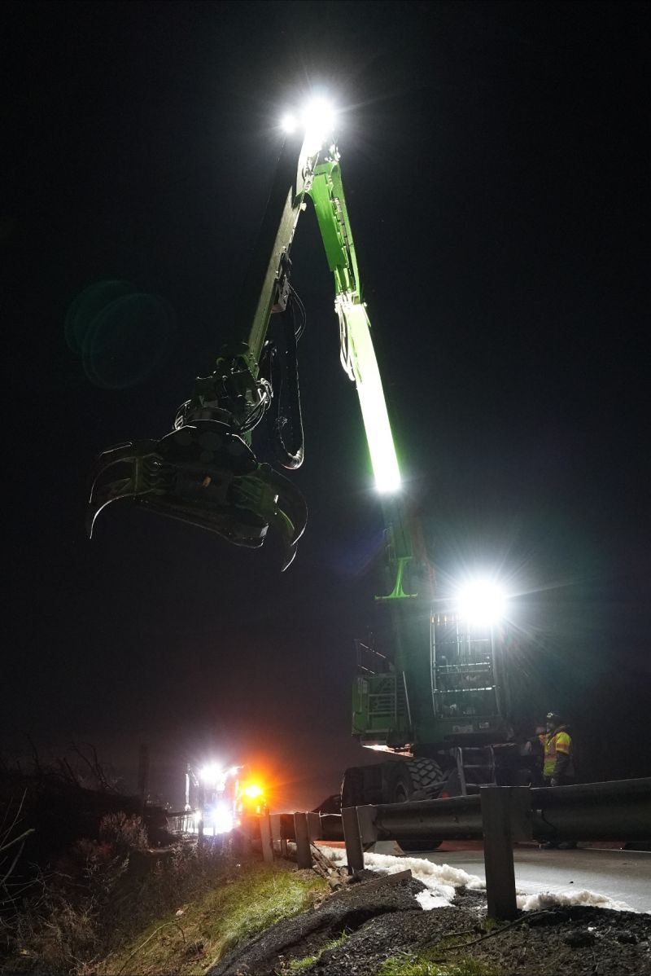

30

65 feet of reach! Just a regular day of working with a SENNEBOGEN 728 R- HD tree care handler.

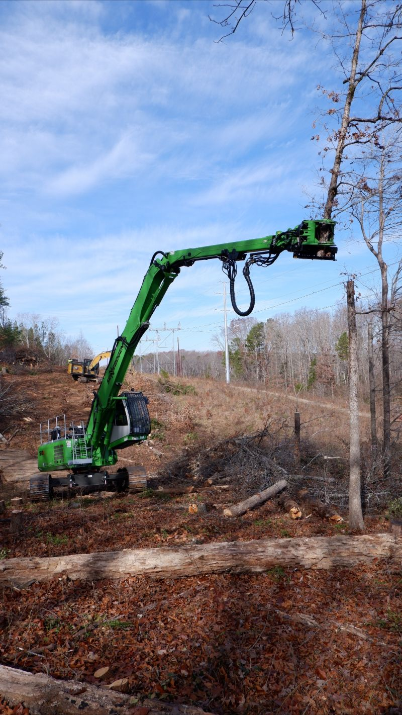

31

Warwick Tree Service in Rhode Island continues to find new opportunities with their SENENBOGEN Tree Care Handlers and are now bringing their power to suburban neighbourhoods.

<https://www.linkedin.com/posts/cameron-kuklick-70a661160_the-always-impressive-warwick-tree-created-activity-7135230863369199617-ICcv/>

32

Meet your new best friend, the SENNEBOGEN 340G Telescopic Wheel Loader. 360-degree visibility, 25 feet of reach and ability to take on multiple jobs, it’s no wonder everyone is raving about this machine. Check out this video at Waste Today.

<https://www.wastetodaymagazine.com/media/sennebogen-340g-telescopic-wheel-loader-sponsored-video/>

33

I could count all the features of the SENNEBOGEN 340G Telescopic Wheel Loader, but this PDF really does say it all! Click to learn all about a wheel loader and a telehandler combining forces into one epic machine.

<https://sennebogen-na.com/wp-content/uploads/dlm_uploads/2023/09/340-G-Series.pdf>

34

A picture is realty worth 1000 words. With Optimal Visibility Conditions, one of the many reasons the SENNEBOGEN 340G Telescoping Wheel Loader is changing the way jobs are getting done more now - more efficiently than ever before.

35

The Institute of Scrap Recycling Industries (ISRI) is out with a fun fact sheet for kids. Check out the Kids Recycling Facts! You can never stop learning.

<https://www.isri.org/docs/default-source/commodities/kids-recycling-fact-sheet_2018.pdf?sfvrsn=2b71a413_16>

36

Sometimes the SENNEBOGEN 8400 Series are blue, sometimes green but whether they are small or large, 718 to the 895 or an 8400 balance crane, in their heart, they are all green machines!

<https://molsongroup.co.uk/green/products/sennebogen-8400-eq/>

37

Sawmill with space constraints? Enter SENNEBOGEN and its purpose-built machines can help solve those issues! A SENNEBOGEN 835 electrically powered machine has helped to increase productivity while proving to be a sustainable answer too.

<https://www.sennebogen.com/en/news/news-press/gantry-solution-in-sawmill-flagship-project-in-switzerland>

38

The 825 R- HDD E Series, is welcomed to the family! SENNEBOGEN’s newest demo machine made its trade fair premiere at IFAT 2024 in Munich, Germany earlier this year. Check it out! <https://www.sennebogen.com/en/news/news-press/all-rounder-demolition-machine-the-new-sennebogen-825-e-demolition>

39

Looking to be amazed? Dazzled? And very likely want to own one of your own and have it featured here?

Have a watch of our YouTube channel. <https://www.youtube.com/user/sennebogenmarketing>

40

“Can’t believe we waited this long to make the switch!”

We hear it often and it is always music to our ears. Going from a traditional excavator to a SENNEBOGEN material handler really does unlock the true potential of your operations.

<https://www.constructionequipmentguide.com/changing-from-excavators-to-sennebogen-waste-handlers-pays-off-for-champion-mrf-operations/57882>

41

An oldie but a goodie! A SENNEBOGEN 830 R- HDD E Series handler making quick work right in the middle of a city centre, really something to behold in such tight quarters.

<https://youtu.be/tgYfCG64Fq8?si=BYs_sEosEYl1lDT0>

42

One SENNEBOGEN machine doing the work of two machines, sounds about right!

A SENNEBOGEN 870 R-HD material handler with a reach of almost 60 feet releasing a 9.5 ton drop ball has made operations more efficient, safer and faster to take on additional work!

<https://www.constructionequipmentguide.com/two-for-one-levys-crawfordsville-site-replaces-two-drop-ball-cranes-with-one-sennebogen-870/58650>