**RBM Event Posts Q4 2023**

1

2024 is off to a great start with the AED Summit happening at the Mirage Hotel & Casino in Las Vegas, NV. SENNEBOGEN will be there from January 15-17 in suite #28052 If you’re involved in construction/demolition, mining, forestry, power generation, stevedoring, agriculture or industrial applications, this is for you!

<https://aedsummit2024.mapyourshow.com/8_0/schedule.cfm#/tab/fullSchedule/date/all/events/>

2

SENNEBOGEN is proud to be a Gold Sponsor of the 2024 MWISA Annual Conference & Trade Show. Can’t wait to be in St. Louis, Missouri from January 24-26 at the Sheraton Westport Lakeside Chalet and connect over arboriculture and SENNEBOGEN’s line of Tree Care handlers. <https://mwisa.org/annual-conference-and-trade-show>

3

C&D World puts on a great event every year. The2024 annual convention and exhibition put on by the Construction & Demolition Recycling Association is shaping up to be no different!

You will find SENNEBOGEN at Booth #300 from January 31 to February 2, 2024, at the Hyatt Regency Coconut Point Resort in Bonita Springs, Florida! We are looking forward to seeing you there.

<https://www.cdraconvention.com>

4

SENENBOGEN will once again be a part of the MVTTC Annual Conference! Entering its 42nd year, we’re thrilled to be in New Orleans, LA for the annual Mississippi Valley Trade & Transport Conference from February 6-8, 2024.

https://mvttc.com/conference

5

We’re heading north to beautiful Huntsville, Ontario (2 hours from Toronto) from February 21-23 for ISAO 2024! The Ontario Chapter of the International Society of Arboriculture is celebrating their 75th anniversary and we cannot wait to be there and talk to you about all the new things happening with the SENNEBOGEN Tree Care line-up!

<https://www.isaontario.com/annual-conference/>

6

Did you see what was on display at the 2023 TCI Expo in St. Louis in the SENNEBOGEN stand? None other than the Albach Diamant 2000. SENNEBOGEN is the distributor for Albach in North America. Let’s chat how the combination of a SENNEBOGEN Tree Care Handler and a Albach Diamant 2000 is a perfect pairing, like apple pie and ice cream. <https://www.linkedin.com/posts/rancho-inc-california_tciexpo-saintlouis-ranchoproud-activity-7132051467267424256-Ywlu>

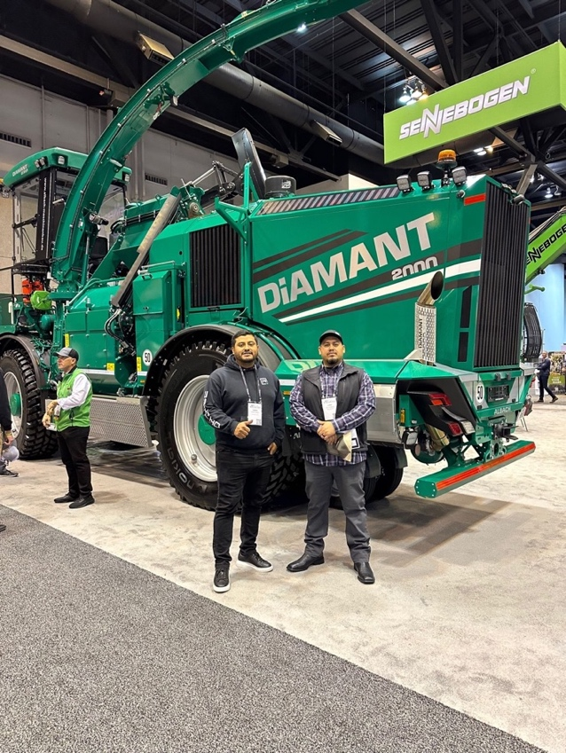

**RBM Posts Q4 2023**

1

New year, new (to you) SENNEBOGEN machine. Check out our Used Machines that are not only supported by our network of Dealers and factory trained Authorized Service Providers but fully supported by SENNEBOGEN too! Plus, these are the only SENNEBOGEN Used Machines on the Market that have full after-sell-support. Don’t be confused by some “grey market” machines.

<https://sennebogen-na.com/used-equipment/>

2

The reviews are in and SENNEBOGEN’s 340 G-Series Telescopic Wheel Loader is winner! Heavy Equipment Magazine called it one of the top equipment product introductions for 2023. Watch it in action.

<https://youtu.be/IRn4fVS9TbQ?si=sduCUUOjoziKGnDa>

3

When you work with SENNEBOGEN machines that have SENNEBOGEN attachments like grapples and magnets, you can rest easy knowing you absolutely have the right attachment for the size of your material handler and will be able to maximize your equipment’s productivity. But our attachments are also 100% compatible with other material handlers. Download the spec sheets or better yet, let us know what you’re looking for.

<https://sennebogen-na.com/product/attachments/?mss-units=us>

4

One machine to do the work of two machines? That’s what SENNEBOGEN’s Vario Tool lets you do. Have a read of this jobsite report from Pacific Steel & Recycling. Increased machine utilization and one less machine to buy!

<https://sennebogen-na.com/pacific-steel-acquires-one-machine-to-do-the-work-of-two-with-sennebogen-vario-tool/>

5

Who better than SENNEBOGEN LLC President Constantino Lannes to demonstrate how our Vario Tool Quick-Change System? It truly is an on-site gamechanger and it only takes 120 seconds to go from scrap shears to loading attachment!

<https://sennebogen-na.com/product/attachments/vario-tool-quick-change-system/?mss-units=us>

6

School is in session. SENNEBOGEN’s Parts and Training Center in Stanley, North Carolina is at the core of our success. Learn more about it and why you should consider becoming a part of the growing alumni!

<https://sennebogen-na.com/recent-announcements/parts-and-training-center-is-at-the-heart-of-sennebogen-success-in-americas/>

7

If you are in the tree care industry anywhere in the world or thinking about it, then you need to see this and learn more about the SENNEBOGEN Tree Care Handlers. Productive. Efficient. Safe, they’ve got it all.

<https://sennebogen-na.com/industries/arborists-arboriculture/>

8

What a beauty cover shot on TCI Magazine! Rancho Tree Service and a SENNEBOGEN 728 E Tree Care Handler, have a peek.

<http://digimag.tcia.org/publication/?m=54984&i=792763&p=1&ver=html5>

9

A SENNEBOGEN 728 Tree Care Handler featured in a recent issue of TCI Magazine, have a read, be amazed and then call me to set up a demo!

<https://tcimag.tcia.org/equipment-technology/sennebogen-728e-tree-care-handler/>

10

It was love at first sight! Mayer Tree Service fell in love with a SENNEBOGEN Tree Care handler and has never looked back, only up, way up!

<https://tcimag.tcia.org/equipment-technology/grapple-on-a-stick-small-safe-and-fast/>

11

ArborWorks and a SENNEBOGEN 718 E Tree Care handler making quick work of this grove of trees, have a watch and enjoy!

<https://youtu.be/vGuTiBvjH70?si=oDy-0_-RFV0_qUqQ>

12

The Raw Metal Corp in Wacol, Queensland (Australia) recycling process has SENNEBOGEN along for the virtually the entire journey <https://www.linkedin.com/posts/rawmetalcorp_exporterworldwide-exporter-scrapmetal-activity-7138044341666676736-q3U7>

13

A beautiful sunrise made even more stunning with a SENNEBOGEN! Kudos to H. W. Green Company, Inc and their operator in Plainville Connecticut for capturing and sharing this moment.

<https://www.linkedin.com/posts/h-w-green-company-inc_hustle-team-vision-activity-7028316290700169216-abuT>

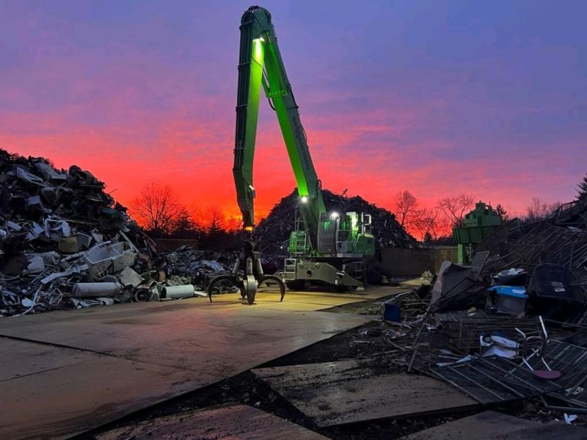

14

2023 witnessed the first ever SENNEBOGEN 875M E in North America. Here’s to many, many, many hours of Tyler Equipment and this material handler doing great things together and SENNEBOGEN with them every step of the way.

https://www.linkedin.com/posts/patrick-huff-4aa831237_sennebogen-matetialhandler-movebigthings-activity-7090066435149832192-Qol4

15

A great peek at the new Sennebogen 340G Telescopic Wheel Loader in Waste Today. With 360-degree visibility, it combines peak performance with optimal safety.

<https://www.wastetodaymagazine.com/media/sennebogen-340g-telescopic-wheel-loader-sponsored-video/>

16

How you like dem apples?! Heavy Equipment Guide named SENNEBOGEN’s 340 G Telescopic Wheel Loader as one of their 2023 Top Introductions! Our newest all-in-one machine brings together the best features of a wheel loader and telehandler and is already ringing in rave reviews on sites across North America!

<https://www.heavyequipmentguide.ca/article/41084/heavy-equipment-guides-2023-top-introductions>

17

The title of this Recycling Product News article sums it up perfectly, “Telehandler or wheel loader? Get both in one machine” Our thoughts exactly!

<https://www.recyclingproductnews.com/article/41171/telehandler-or-wheel-loader-get-both-in-one-machine>

18

Visionary, pioneer, history-maker!

Dan Mayer of Mayer Tree Service was the first to own a Sennebogen 718 Tree Care handler, now the first to own a SENNEBOGEN 340 G Telescopic Wheel Loader.

<https://www.linkedin.com/posts/greg-roberts-8ab8744_great-times-catching-up-today-with-dan-mayer-activity-7141162641934188544-pxum>

19

Pacific Material Handling in Laverton North, Australia showing every single day how a SENNEBOGEN 830 M E with a trailer and an 875E Hybrid go together like peanut butter and jelly!

<https://www.linkedin.com/posts/pacific-materials-handling_sennobogen-timberhandling-innovation-activity-7140813790551457792-Nx5l>

20

Saying goodbye to a legend but welcoming its successor. The last SENNEBOGEN 880 EQ balance material handler was recently delivered in Turkey to work along side the first one that was ordered back in 2007. However, like all good things, it has evolved into the 885G that incorporates the SENNEBOGEN Green Hybrid Energy Recovery System. With a reach of up to 38 m, port handling operations are witness to a whole new world of productivity.

<https://www.sennebogen.com/en/news/news-press/the-last-of-its-kind-the-last-880-eq-leaves-the-factory>

21

What do you do when you are celebrating your 71st anniversary in business? You open the doors and invite everyone to see all the things you have done and are doing. Check out the story in Awesome Earthmovers.

<https://cloud.3dissue.net/39898/39768/40184/101289/?page=19>

22

Be a Rock Star Port Manager. Download this handy PDF with a ton of information and resources to increase productive, safety and your bottom line.

<https://info.sennebogen-na.com/port-optimized-operational-efficiency>

23

We are SENNEBOGEN. 71 years and going strong because it’s the WE that counts.

<https://youtu.be/G7ngyKcjFzg?si=HdRq5OribVp3-Wgl>

24

From start to forever. When you buy a SENNEBOGEN, it really is “Beyond the Machine” and it’s our commitment to you.

<https://sennebogen-na.com/beyond-the-machine/>

25

Be aware, there are brokers representing themselves as authorized SENNEBOGEN dealers and they’re not and at the same time misrepresenting the true condition of the machines in their inventory.

When considering the purchase of a used SENNEBOGEN, please contact [sales@sennebogenllc.com](mailto:sales@sennebogenllc.com) or reach out to me directly at no cost so we can alleviate any concerns. SENNEBOGEN President Constantino Lannes goes into more detail, please follow the link.

<https://sennebogen-na.com/recent-announcements/brokers-are-importing-and-marketing-used-sennebogen-machines-misrepresenting-their-true-condition/>

26

Congrats to Envimat for 2023 Dealer of the Year! The name truly says it all…

**Envi**ronment and **Mat**erial Handling.

<https://sennebogen-na.com/recent-announcements/envimat-bringing-knowledge-helps-customers-save-money-and-the-environment/>

27

Register to watch an online demo of SENNEBOGEN’s 718, 728 and 738 Tree Care Handlers in action! This could be the first step to increasing your income by 3x and your productivity by 10x!

[SENNEBOGEN Tree Handlers Online Demo (sennebogen-na.com)](https://info.sennebogen-na.com/tree-handlers-online-demo-lp)

28

### We don’t like downtime, but we love uptime! I guess that’s why we call them UPtime Kits. Learn more about SENNEBOGEN’s UPtime kits.

Each kit combines all the parts and materials required to complete a type of specific maintenance task. Delivered in custom organizers, pre-sorted for easy identification, they are designed to save time, save money, and streamline every service requirement with pre-packaged parts kits matched to your machine.

<https://sennebogen-na.com/parts-service/parts-supply/>

30

SENNEBOGEN Capital offers unique financing options including…

* Lease by the Hour®
* Full Payout Loan
* A Fixed Price Purchase Option
* A Tax or True Lease Option.

Because we understand your business and appreciate that each one is different. Ask us what’s best for you and your continued growth!

<https://sennebogen-na.com/about/financing/>