# | Copy | Destination URL
1 | One of the SENNEBOGEN Tree Care specialists was recently out in the field, setting up a new customer with their 718. Check out the action in this video. It tells a great story. | https://www.linkedin.com/posts/cameron-kuklick-70a661160_this-week-i-had-the-pleasure-of-gearing-up-activity-7194796132890198017-Hrrm/
2 | Daytime. Nighttime. Anytime. A SENNEBOGEN Tree Care handler will always be ready to go! | 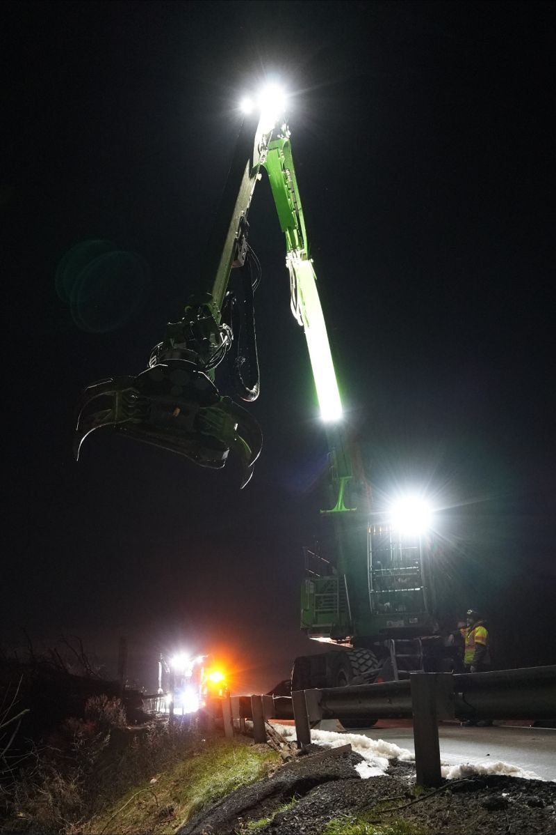
3 | Tree care work is challenging and unforgiving. That is why the SENNEBOGEN Tree Care handlers have been engineered with safety as a top priority. Learn more about their commitment to safety here. | https://sennebogen-na.com/why-sennebogen/safety/
4 | The SENNEBOGEN Uptime Kits continue to impress me. Versatile, easy to take on jobs and, most importantly, time-saving. Get the job done with all the necessary parts and tools to keep you going! | https://sennebogen-na.com/parts-service/parts-supply/
5 | When you buy a SENNEBOGEN Tree Care handler, you get the complete after-sales support team. The level of service is remarkable. | https://sennebogen-na.com/wp-content/uploads/2023/06/Sennebogen-Value-Adds-Brochure.pdf
6 | Have you heard about SENNEBOGEN’s Lease by the Hour® program? It’s ideal for adding a Tree Care handler to your fleet without having to guess the # of hours. Ask me questions and I will be happy to answer them! | https://sennebogen-na.com/about/financing/
7 | Here’s a great jobsite report about a SENNEBOGEN user and their tree care machine.  Moral of the story: A 718 M E Series machine can generate A LOT of growth for your business. | https://sennebogen-na.com/jobsite-reports/productivity-gains-with-sennebogen-718-are-no-joke-in-urban-tree-trimming-projects?mss-units=us

